**Advanced Petrophysics PGE 381L, Fall 2023**

**Unique Number: 20215**

# Homework Assignment No. 3

September 14, 2023

Due on September 28, 2023, before 11:00 PM

Name: **RENATO ESPIRITO BASSO POLI**

UT EID: **rep2656**

**Objectives:**

1. To practice assessment of porosity and fluid saturations in-situ condition
2. To practice calculation of hydrocarbon reserves
3. To practice assessment of fluid saturation in the presence of shale

**Coursework Copyright Policy:** Handouts and data used in this course are copyrighted. The designation "handouts" includes all the materials generated for this class, which include but are not limited to syllabus, quizzes, data, exams, solution sets, laboratory problems, in-class materials, PowerPoint presentations, PDF files, review sheets, additional problem sets, and digital material. Because these materials are copyrighted, students do not have the right to copy them, reproduce them (including digital reproductions), post them on the web, or share them with anyone by either manual or electronic means unless you are expressly granted permission by the instructor.

**Note:** Please scan your homework assignment and upload it as one pdf file on the Canvas website before the deadline. Please name your homework document as follows:

*PGE381L_2023_Fall _HW03_lastname_name.pdf*

Example: PGE381L_2023_Fall_HW03_Heidari_Zoya.pdf

**Question 1:** Consider the well logs provided to you in Excel format, named “Question1_data.” Answer the following questions:

*Note: Please do not use any well-log interpretation software. You can assume a = 1, m =2, n = 2*

1. Plot the well logs similar to the example distributed in the class (Example 1). Pay attention to the scale.

*Question to think about (will not be graded): Do you know the reason behind the choice of scale for plotting bulk density, when plotted on top on neutron porosity in sandstone units versus the case it is plotted against neutron porosity in sandstone units?*

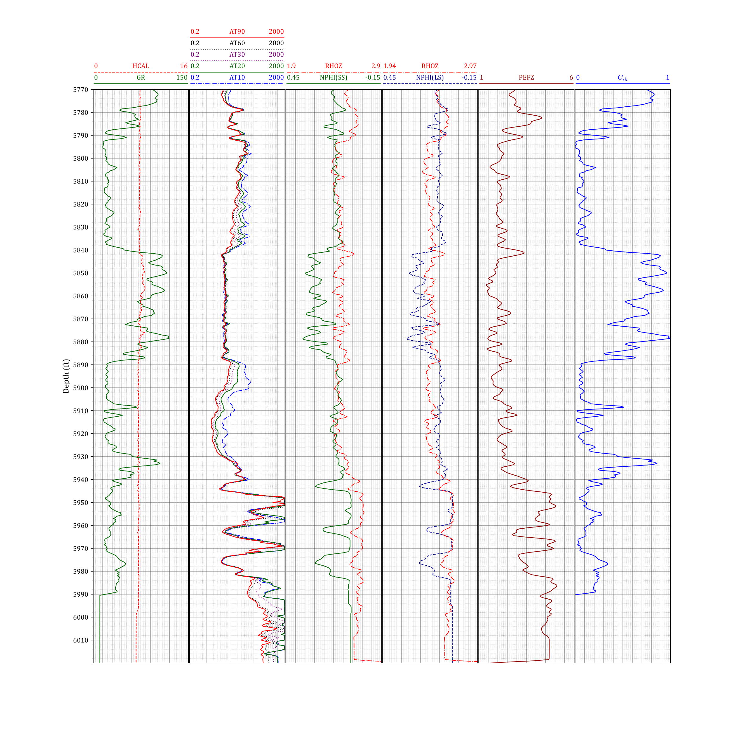

1. Calculate the volumetric concentration of shale at each depth via

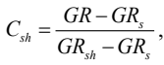

where and are the gamma ray readings in clay-free sand and pure shale, respectively.

Reading from the logs

1. Using the density log, calculate the porosity at each depth. Make appropriate assumptions for matrix and fluid densities. Plot the estimated depth-by-depth water saturation next to your well logs.

*Consider 85% Illite and rest Chlorite clay type in shale.*

*You can assume that 70% of the matrix in shale is composed of clay and the rest is silt.*

What type of porosity are you calculating using the density log? Total or effective?

First we need to convert the logs to :

where is the bulk density, is the matrix density and is the fluid density.

From tables:

The following properties are used:

|  |  |
| --- | --- |
|  |  |
| Sandstone | 2.65 |
| Shale | 2.68 |
| Limestone | 2.71 |

1. Identify the water-oil contact.
2. Figure 1 shows deep resistivity measurements versus porosity for the water-saturated zone in this formation. This plot is called Pickett plot. Estimate the formation water resistivity using the data provided Figure 1.

Let , (water saturated zone):

We read the graph @ .

Hence, using the formula,

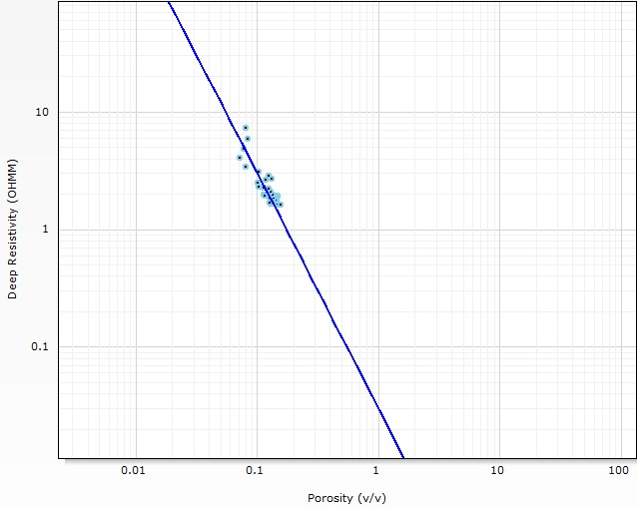

**Figure 1:** Pickett plot for Question 1-e

1. Estimate water/hydrocarbon saturation at each depth. Plot the estimated depth-by-depth water saturation next to your well logs. Plot the estimated depth-by-depth oil saturation next to your well logs. Note that shales are fully water saturated. You do not need to perform calculations for shale zones.

1. Estimate total hydrocarbon reserves in place (in bbls/unit area).

1. **Bonus Question:** Estimate movable hydrocarbon saturation at each depth. Plot your results. What are the uncertainties associated with your interpretation?

**Question 2:** A series of core measurements from a well provided the formation factor versus porosity data as listed in the following table:

|  |  |
| --- | --- |
| **Formation Resistivity Factor** | **Porosity** |
| 30 | 0.092 |
| 19.3 | 0.12 |
| 12.5 | 0.165 |
| 8.4 | 0.205 |
| 6 | 0.268 |

A thick salt water bearing layer of the reservoir is encountered in an offset well with a resistivity of 1.79 ohm-m. If the resistivity of the salt water is 0.076 ohm-m, estimate the porosity of the water bearing layer.

**Question 3: Figure 2** shows a synthetic porous medium which is made of insulator material and is shaped as a cube of length L. Three cylindrical shape tubes of radius *r* are drilled through the middle of this cube. You can assume:



Two of the cylindrical tubes are filled with brine of resistivity *Rw*, and the third one is filled with oil. Answer the following questions:

1. Calculate the formation resistivity factor (*F*), and the resistivity index (*I*) for the porous medium in the direction parallel to the length of the cylindrical tubes.
2. Determine the relationship between formation factor and porosity.
3. How does this compare with Archie’s equation?

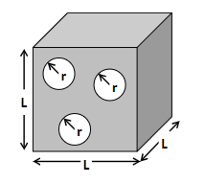

**Figure 2:** A synthetic porous medium. White and grey regions represent pores and insulator material, respectively.

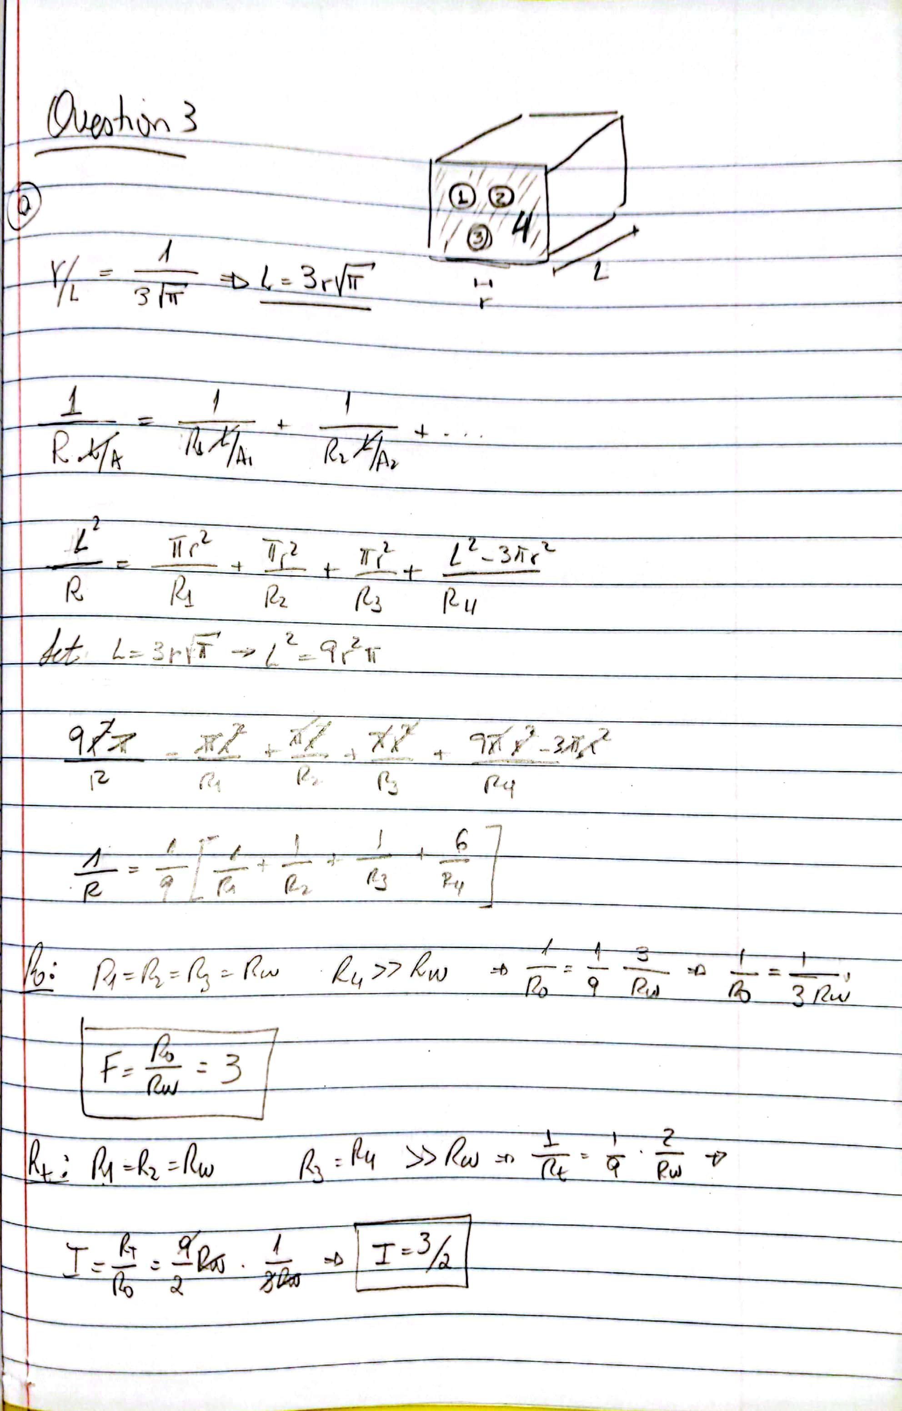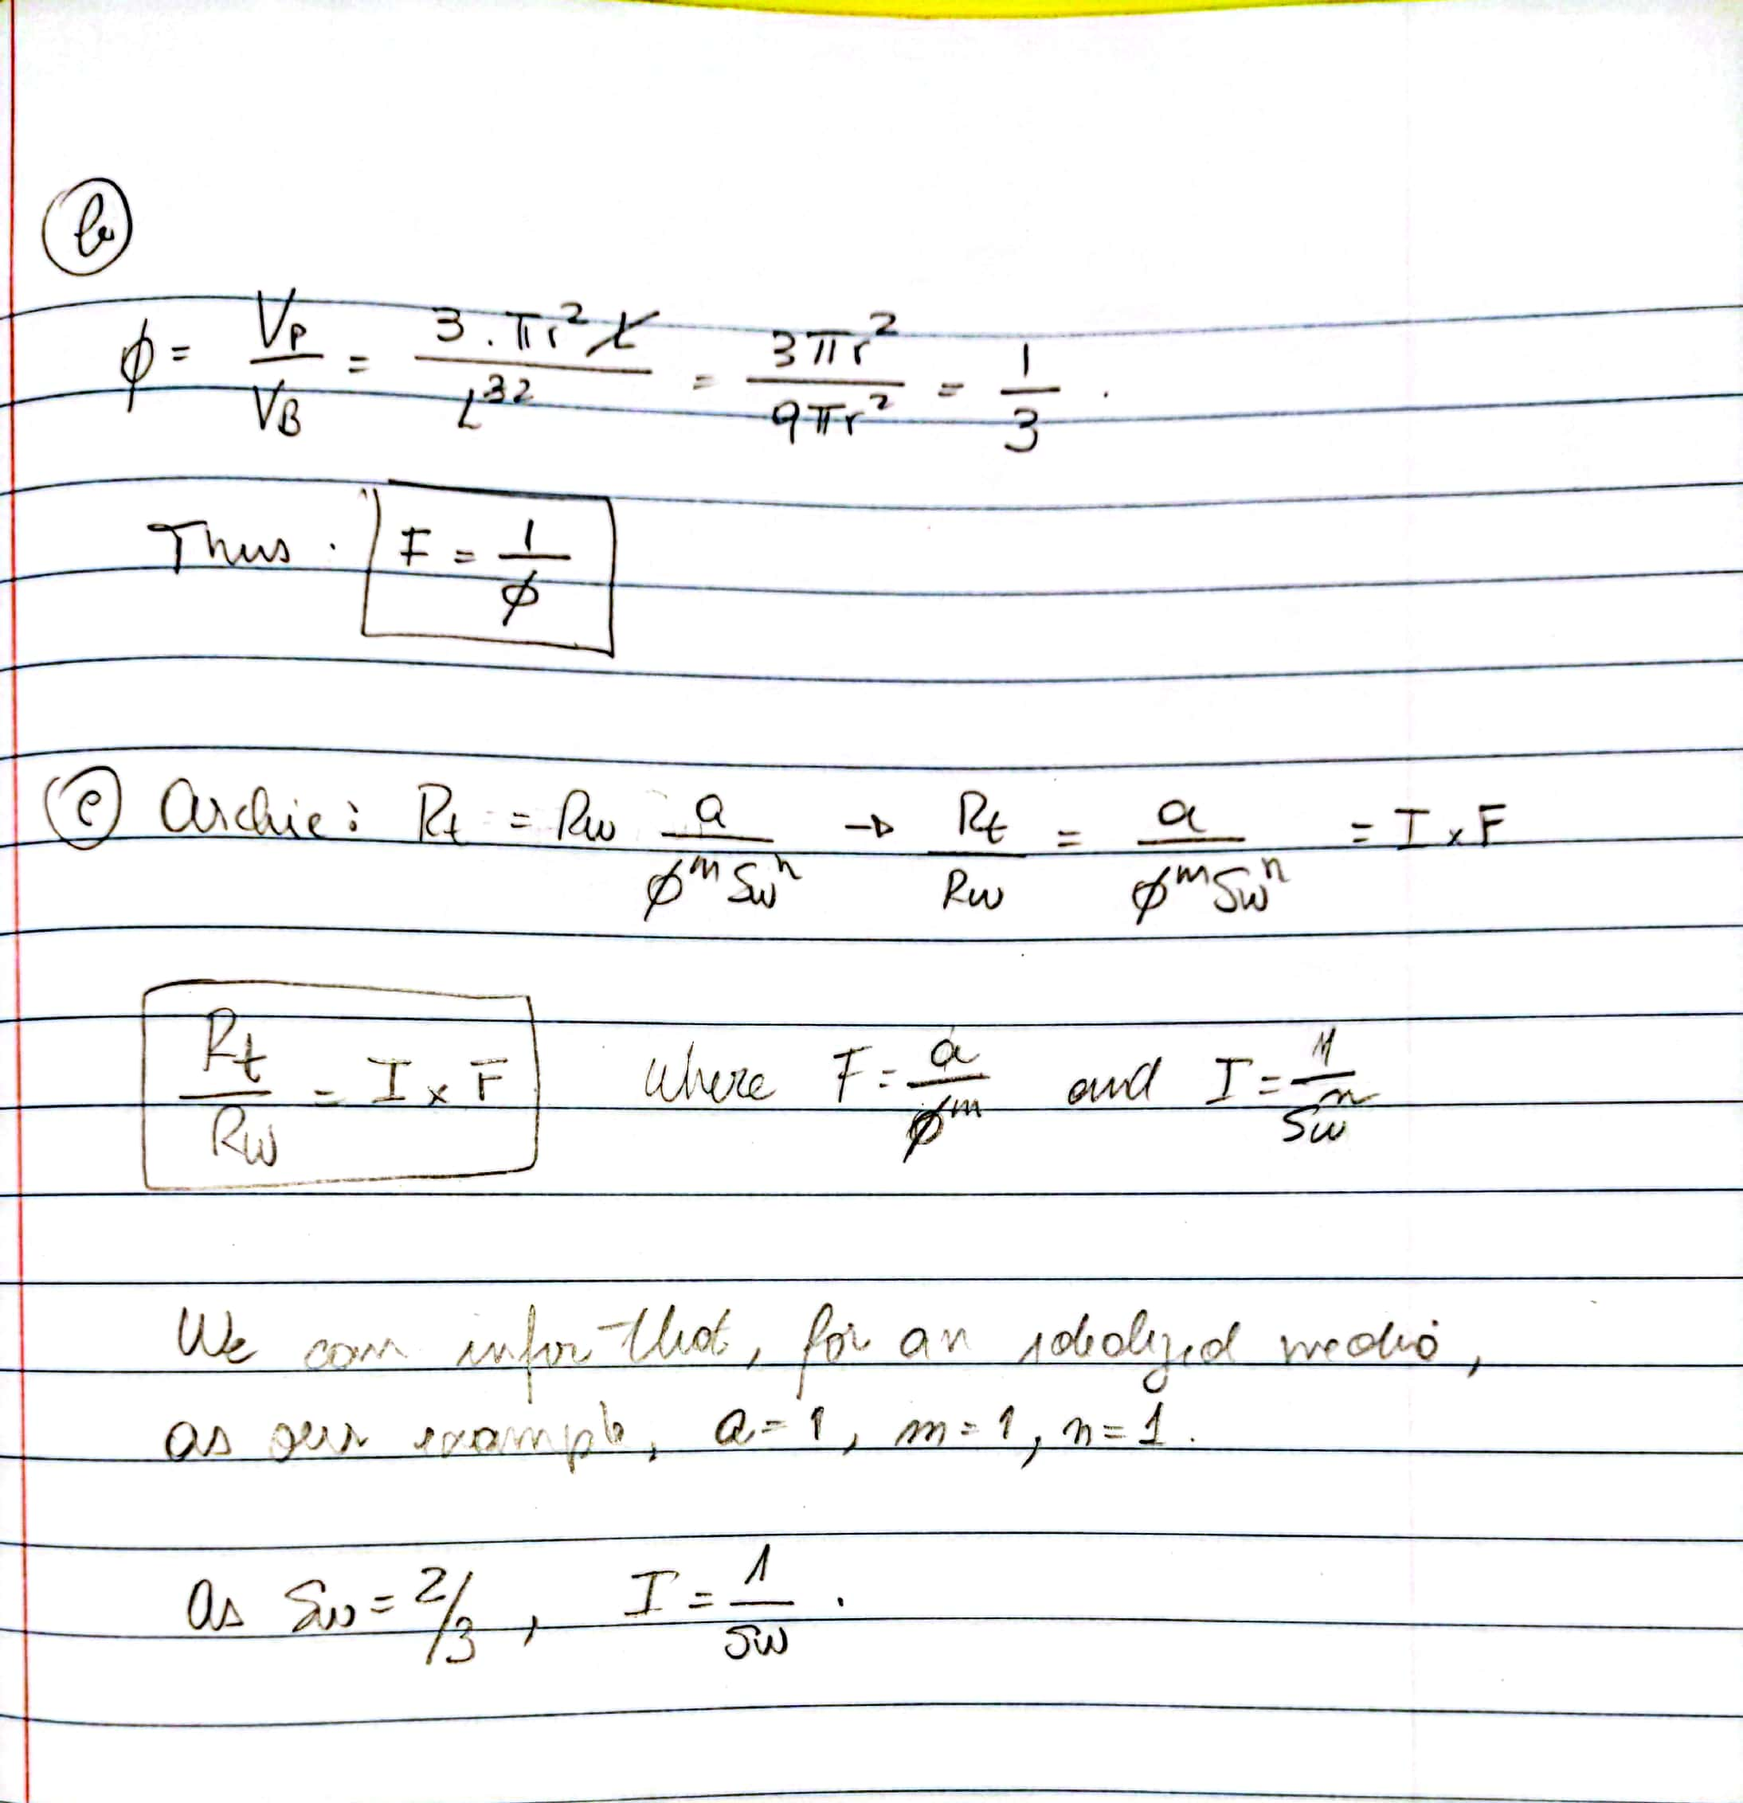

**Question 4:** We know that negative charge on the surface of clay minerals can cause variation (from surface of the clay mineral to the center of the pore) in electrical conductivity of water.

**Figure 2** is a simplified illustration to model this variation in electrical conductivity of water in porous media by assuming two parallel layers of water. You can assume the electrical conductivity of clay-bound water layer is σwb and the electrical conductivity of formation water layer is σw. Saturation of clay-bound water is equal to *Swb*.

Answer the following questions:

1. Estimate equivalent electrical conductivity of water, σw,avg, in the presence of clay minerals. You can assume the pore space is fully saturated with water.
2. Update Archie’s equation by taking into account your updated electrical conductivity of water. You can assume the pore space is fully saturated with water.
3. How would you update your resistivity model in part (b), if there is hydrocarbon in the system? You can assume total saturation of water and hydrocarbon are *SWT* and *SHC*, respectively. Write your new model.



**Clay**

**Mineral**



**Clay**

**-**

**bound**

**water**

**Formation**

**water**

## Figure 2

**Question 5:** Consider the well logs in Example 2, of the well-log package which is distributed in the class. This is a laminated shaly-sand formation.

Answer the following questions for depth 5522 ft. You can consider the following readings for well-log measurements: Resistivity = 2.8 ohm-m (This is equivalent to horizontal resistivity).

1. Estimate hydrocarbon saturation at 5522 ft.
2. Estimate density of hydrocarbon at 5522 ft.
3. Estimate hydrocarbon pore volume per unit depth.
4. In the last three parts, it is expected that you take into account shale laminations in your calculations. Now assume that you use the measured resistivity without taking into account the impact of shale. What would be the relative error in estimate of hydrocarbon saturation, compared to what you obtained in part (a)?